The Effect of Marijuana on Hypertension
P1 - Presentation of the Research Topic & Hypothesis
Bryon Langford, Matthew Hoctor

Hypothesis & Rationale

The purpose of the proposed study is to investigate the possible relation between marijuana use (both recreational and medicinal) and hypertension, and to determine if this effect differs based on gender. Our hypothesis is that frequency of marijuana use is associated with increased blood pressure, as previous research using NHANES data has shown this association.¹ Our exposed group is defined to be adults living in the United States who use cannabis, and our referent group is defined to be adults living in the United States who do not use cannabis. Furthermore we hypothesize that this effect, if replicated in our analysis, will be modified by gender, and will be stronger in males than in females.

Directed Acyclic Graph

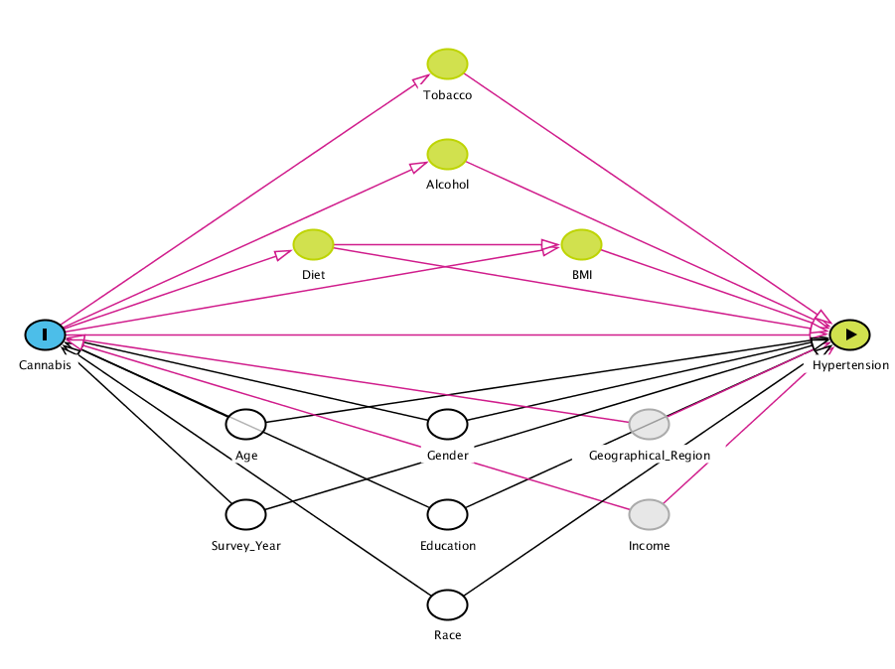
Legend:
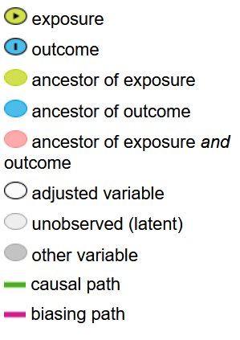

Gender, age, race, education, and survey year have plausible correlations with both exposure and outcome, and thus are conceptualized as confounders. Furthermore, these variables were found to be confounders in the previous NHANES research on this topic.¹ Please note that gender is hypothesized to be an effect modifier as well as a confounder. Education may also be an effect modifier. As cannabis use plausibly changes alcohol use, tobacco use, diet, and body mass index, these variables are conceptualized as mediators. Geographical region and education (not shown) are key unmeasured confounders, as prevalence of hypertension and cannabis use vary significantly by education and region.^{2–4}

Burden of Hypertension

Hypertension is thought to be the most significant modifiable risk factor for atherosclerotic cardiovascular disease in U.S. adults, even surpassing smoking.⁵ Hypertension is a well known risk factor for kidney disease, coronary heart disease, and stroke; with associated population attributable risks of 34%,⁶ 25%,⁷ & 30%⁸ respectively. Nearly half of US adults have hypertension, according to the definition in the 2017 American Heart Association/American College of Cardiology guidelines.⁹ Based on Medical Expenditure Panel Survey data, patients with hypertension have greater yearly medical expenditures by almost $2,000, for an estimated yearly cost of $131 billion (in 2014 USD).¹⁰ Therefore hypertension is responsible for a great proportion of the burden of disease in the United States, and every effort should be made to understand its epidemiology, prevention, and management.

Biological & Social Mechanisms

Marijuana use may affect blood pressure by a variety of mechanisms. Tetrahydrocannabinol (THC) acutely causes increased heart rate and cardiac output leading to increased blood pressure,¹¹ whereas cannabidiol causes vasodilation, but does not acutely affect blood pressure.¹² Chronic administration of high THC cannabis products are hypothesized by the authors to cause hypertension via downregulation of transient receptor potential cation channel subfamily V member 1 (TRPV-1) receptors on sensory vagal nerves in the heart. Sex hormones interact with phytocannabinoids in multiple ways,¹³ and this is hypothesized to lead to effect measure modification by gender.

Public Health Impact

The effect of marijuana use on cardiovascular risk is not fully understood,^{14–16} and the interaction between gender and marijuana use on the development of hypertension has not been studied observationally. Marijuana use has apparent beneficial metabolic effects,¹⁵ but further study is needed to assess the expected results of increasing marijuana use⁴ on population level cardiometabolic risk. Gender differences have been frequently observed in the biological and behavioral effects of marijuana use. For example, males consume marijuana in greater amounts and at higher rates than females.¹⁷ Male marijuana smokers exhibit higher circulating levels of THC¹⁸ and show larger cardiovascular effects than female smokers.¹⁹ Males also have a higher incidence of hypertension compared to females of the same age until the occurrence of menopause (due in part to the protective effect of estrogen).²⁰ Therefore, it is likely that the association between marijuana use and hypertension is strongest among males.

References

1. Vidot DC, Powers M, Gonzalez R, et al. Blood Pressure and Marijuana Use: Results from a Decade of NHANES Data. Am J Health Behav. 2019;43(5):887-897. doi:10.5993/AJHB.43.5.2
2. CDC. Facts About Hypertension | cdc.gov. Centers for Disease Control and Prevention. Published September 8, 2020. Accessed June 27, 2021. https://www.cdc.gov/bloodpressure/facts.htm
3. National Conference of State Legislatures. State Medical Marijuana Laws. Published June 23, 2021. Accessed June 27, 2021. https://www.ncsl.org/research/health/state-medical-marijuana-laws.aspx
4. Center for Behavioral Health Statistics and Quality. 2019 National Survey on Drug Use and Health: Detailed Tables | CBHSQ Data. Substance Abuse and Mental Health Services Administration; Health and Human Services; 2020. Accessed June 28, 2021. https://www.samhsa.gov/data/report/2019-nsduh-detailed-tables
5. Danaei G, Ding EL, Mozaffarian D, et al. The Preventable Causes of Death in the United States: Comparative Risk Assessment of Dietary, Lifestyle, and Metabolic Risk Factors. PLoS Med. 2009;6(4):e1000058. doi:10.1371/journal.pmed.1000058
6. Saran R, Li Y, Robinson B, et al. US Renal Data System 2014 Annual Data Report: Epidemiology of Kidney Disease in the United States. Am J Kidney Dis Off J Natl Kidney Found. 2015;66(1 Suppl 1):Svii-305. doi:10.1053/j.ajkd.2015.05.001
7. Cheng S, Claggett B, Correia AW, et al. Temporal Trends in the Population Attributable Risk for Cardiovascular Disease: The Atherosclerosis Risk in Communities Study. Circulation. 2014;130(10):820-828. doi:10.1161/CIRCULATIONAHA.113.008506
8. Willey JZ, Moon YP, Kahn E, et al. Population attributable risks of hypertension and diabetes for cardiovascular disease and stroke in the northern Manhattan study. J Am Heart Assoc. 2014;3(5):e001106. doi:10.1161/JAHA.114.001106
9. Ritchey MD, Gillespie C, Wozniak G, et al. Potential need for expanded pharmacologic treatment and lifestyle modification services under the 2017 ACC/AHA Hypertension Guideline. J Clin Hypertens. 2018;20(10):1377-1391. doi:10.1111/jch.13364
10. Kirkland EB, Heincelman M, Bishu KG, et al. Trends in Healthcare Expenditures Among US Adults With Hypertension: National Estimates, 2003–2014. J Am Heart Assoc Cardiovasc Cerebrovasc Dis. 2018;7(11):e008731. doi:10.1161/JAHA.118.008731
11. Jones RT. Cardiovascular System Effects of Marijuana. J Clin Pharmacol. 2002;42(S1):58S-63S. doi:10.1002/j.1552-4604.2002.tb06004.x
12. Baranowska-Kuczko M, Kozłowska H, Kloza M, et al. Vasodilatory effects of cannabidiol in human pulmonary and rat small mesenteric arteries: modification by hypertension and the potential pharmacological opportunities. J Hypertens. 2020;38(5):896-911. doi:10.1097/HJH.0000000000002333
13. Dobovišek L, Hojnik M, Ferk P. Overlapping molecular pathways between cannabinoid receptors type 1 and 2 and estrogens/androgens on the periphery and their involvement in the pathogenesis of common diseases (Review). Int J Mol Med. 2016;38(6):1642-1651. doi:10.3892/ijmm.2016.2779
14. Bondarenko AI. Cannabinoids and Cardiovascular System. In: Bukiya AN, ed. Recent Advances in Cannabinoid Physiology and Pathology. Vol 1162. Advances in Experimental Medicine and Biology. Springer International Publishing; 2019:63-87. doi:10.1007/978-3-030-21737-2_5
15. National Academies of Sciences, Engineering, and Medicine, Health and Medicine Division, Board on Population Health and Public Health Practice, Committee on the Health Effects of Marijuana: An Evidence Review and Research Agenda. The Health Effects of Cannabis and Cannabinoids: The Current State of Evidence and Recommendations for Research. National Academies Press (US); 2017. Accessed June 23, 2021. http://www.ncbi.nlm.nih.gov/books/NBK423845/
16. Kicman A, Toczek M. The Effects of Cannabidiol, a Non-Intoxicating Compound of Cannabis, on the Cardiovascular System in Health and Disease. Int J Mol Sci. 2020;21(18):6740. doi:10.3390/ijms21186740
17. Perez-Reyes M, Owens SM, Di Guiseppi S. The clinical pharmacology and dynamics of marihuana cigarette smoking. J Clin Pharmacol. 1981;21(S1):201S-207S. doi:10.1002/j.1552-4604.1981.tb02596.x
18. Jones AW, Holmgren A, Kugelberg FC. Driving under the influence of cannabis: a 10-year study of age and gender differences in the concentrations of tetrahydrocannabinol in blood. Addict Abingdon Engl. 2008;103(3):452-461. doi:10.1111/j.1360-0443.2007.02091.x
19. Leatherdale ST, Hammond DG, Kaiserman M, Ahmed R. Marijuana and tobacco use among young adults in Canada: are they smoking what we think they are smoking? Cancer Causes Control CCC. 2007;18(4):391-397. doi:10.1007/s10552-006-0103-x
20. Ashraf MS, Vongpatanasin W. Estrogen and hypertension. Curr Hypertens Rep. 2006;8(5):368-376. doi:10.1007/s11906-006-0080-1
21. Goyal H, Awad HH, Ghali JK. Role of cannabis in cardiovascular disorders. J Thorac Dis. 2017;9(7):2079-2092. doi:10.21037/jtd.2017.06.104
22. Pacek LR, Mauro PM, Martins SS. Perceived risk of regular cannabis use in the United States from 2002 to 2012: differences by sex, age, and race/ethnicity. Drug Alcohol Depend. 2015;149:232-244. doi:10.1016/j.drugalcdep.2015.02.009

